Sepsis Updates

New to EPIC: Sepsis Timer!
This will allow you to see a red clock on your dashboard when you have placed a sepsis bundle orderset. When the nurse has completed the bundle, the red clock will turn to a green check mark. (See attached Tip Sheet)
Fluid Exceptions
We do a great job at treating patients- CMS is not as smart as you! But- CMS sees sepsis as either a “pass or fail.” We have a lot of fall outs for not documented rationale regarding fluids* administration. Use the .sepsisfluidexception dot phrase to help alleviate charting.
*Remember, this only applies to those patients that meet the 30cc/kg criteria (hypotension/lactate >=4). You must document your rationale AND how much fluid you ordered if you are not giving 30cc/kg in this cohort.
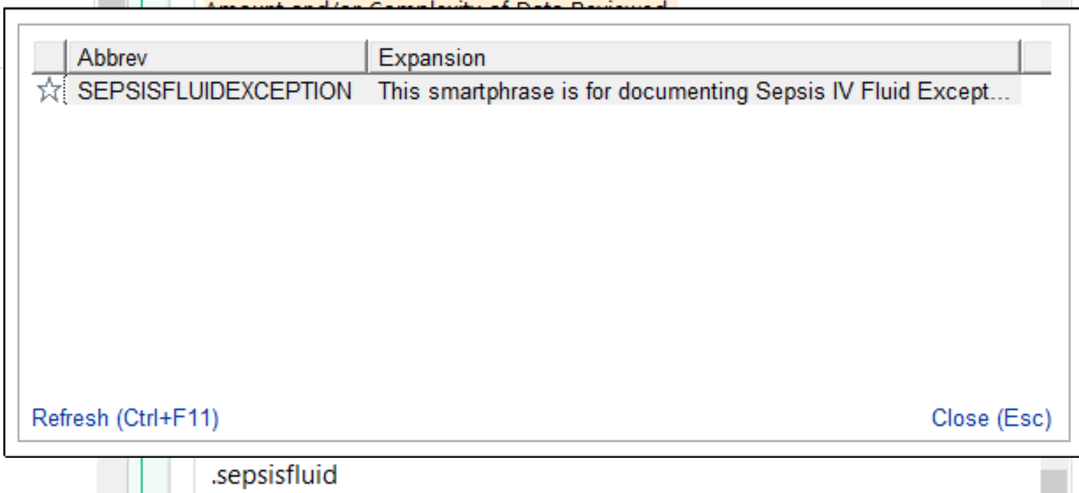
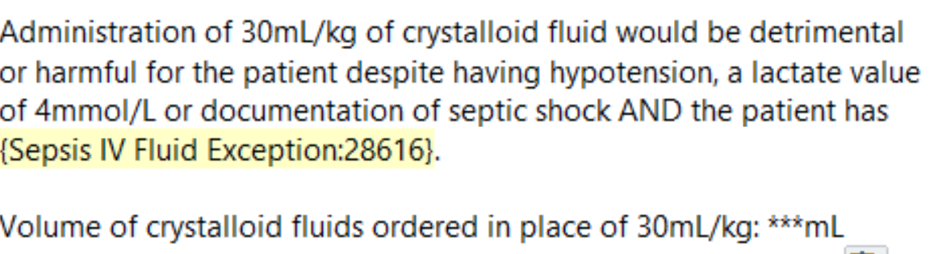

FYI- ideal body weight is accepted. See Q&A below. This is an option when ordering fluids in the orderset in EPIC. Documentation is key.
Q “Does the targeted fluid volume still allow for using ideal body weight (IBW) if the body mass index (BMI) is greater than 30?
A Yes, the guidance in the Crystalloid Fluid Administration data element continues to allow for the use of IBW to determine the target ordered volume when there is physician/APN/PA documentation of obesity or a BMI greater than 30.”

CMS SEP-1 Algorithm for your reference:
